**hw_10**

1. **What does the "dilation" in Convolution control? (b)**
2. Output size
3. Down-Sampling rate
4. Dropout rate
5. Remove outliers
6. Extract features
7. **When receiving the input_tensor below as an input, the result of each mode is as follows. Choose the appropriate mode for (1) and (2). (d)**

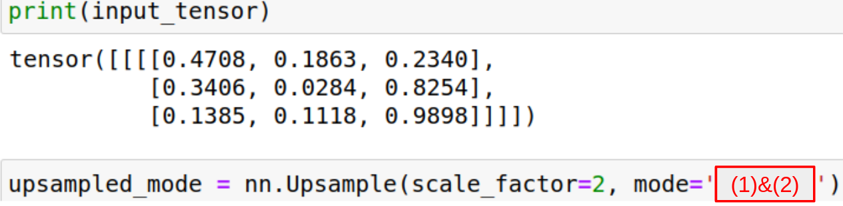

|  |  |
| --- | --- |
| (1) | (2) |
|  |  |

1. (1) transpose, (2) nearest
2. (1) nearest, (2) bilinear
3. (1) transpose, (2) bilinear
4. (1) bilinear, (2) nearest
5. **Using the concept of Transposed Convolution, fill in the values of (1), (2) and (3) below(padding = 1, stride = 2).(a)**

|  |  |
| --- | --- |
| input(2x2) | filter(3x3) |
| |  |  | | --- | --- | | 1 | 2 | | 3 | 4 | | |  |  |  | | --- | --- | --- | | 1 | 0 | -1 | | 1 | 0 | -1 | | 1 | 0 | -1 | |

|  |
| --- |
| output(6x6) |
| |  |  |  |  |  |  | | --- | --- | --- | --- | --- | --- | |  |  |  |  |  |  | |  | 0 | 1 | 0 | -2 |  | |  | 0 | (1) | 0 | (2) |  | |  | 0 | 1 | 0 | (3) |  | |  | 0 | 1 | 0 | -4 |  | |  |  |  |  |  |  | |

1. (1) 2 ,(2) -6 ,(3) -4
2. (1) -2 ,(2) -6 ,(3) -4
3. (1) 2 ,(2) 6 ,(3) 4
4. (1) 2 ,(2) -6 ,(3) 4

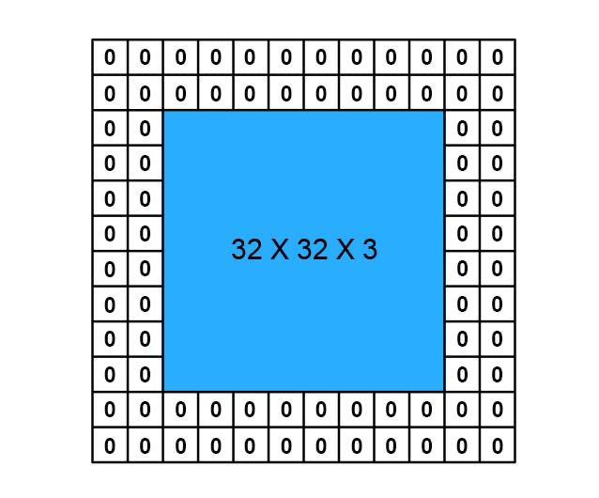

1. **What is the number of parameters in the picture above? (with 6x6x32 filters, stride=2) (d)**
2. 1,728
3. 1,744
4. 3,456
5. 3,488
6. **What is the output volume size in the picture above? (with 6x6x32 filters, stride=2) (e)**
7. 9
8. 10
9. 12
10. 15
11. 16

or… 4+5

1. **What is the output volume size and number of parameters in the picture above? (with 6x6x32 filters, stride=2) (f)**

|  |  |  |
| --- | --- | --- |
|  | Output volume size | Number of parameters |
| a | 9 | 1,744 |
| b | 9 | 3,488 |
| c | 12 | 1,744 |
| d | 12 | 3,456 |
| e | 16 | 3,456 |
| f | 16 | 3,488 |